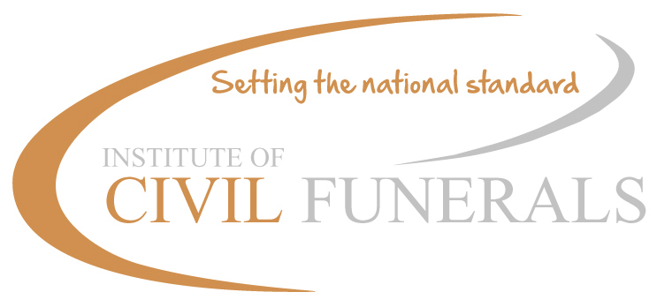

IoCF Best Practice
Saturday 18th April, The Claret Centre, The Towers, Buckden, St Neots, Cambs. PE19 5TA
Tel: 01480 810344 Email: claret_centre@claret.org.uk

Booking Form

Please return completed form to:
BPDIOCF - 2014
The Institute of Civil Funerals, 6 Nene Road, Bicton Industrial Park, Kimbolton, Cambs, PE28 0LF or
barbara@iocf.org.uk
Please return your booking no later than Friday 3rd April

ALL BOOKINGS MUST BE ACCOMPANIED BY PAYMENT (cheque or BACS)

Please reserve a place for (Name of Attendee):

Local Authority Name/Employing Organisation (If applicable)
Best Practice Day £65
Please make cheques payable to: The Institute of Civil Funerals (Receipted invoices will be given to you at the day)
Or BACS to: Sort code: 30-94-47 Account number: 03038542

Special Dietary Requirements

Any other special requirements

Thank you.

Signed ……………………………………………… Date

